EXPERIMENT NO : 01
Name: Anjali Nagesh Karpe
Roll no.: 24141025
Batch: I2

Title: Binary search techniques using array and recursion. Analyse time and space
complexity.

- Binary search using Array.

#include <stdio.h>
int binarySearch(int arr[], int n, int key) {
int low = 0, high = n - 1;

while (low <= high) {
int mid = (low + high) / 2;

if (arr[mid] == key)
return mid;

else if (arr[mid] < key)
low = mid + 1;

else
high = mid - 1;
}

return -1;
}
int main() {
int n, key, result;
printf("Enter number of elements: ");
scanf("%d", &n);
int arr[n];
printf("Enter elements in sorted order: ");
for (int i = 0; i < n; i++) {
scanf("%d", &arr[i]);
}
printf("Enter element to search: ");
scanf("%d", &key);
result = binarySearch(arr, n, key);
if (result == -1)
printf("Element not found\n");
else
printf("Element found at index %d\n", result);

return 0;
}
OUTPUT

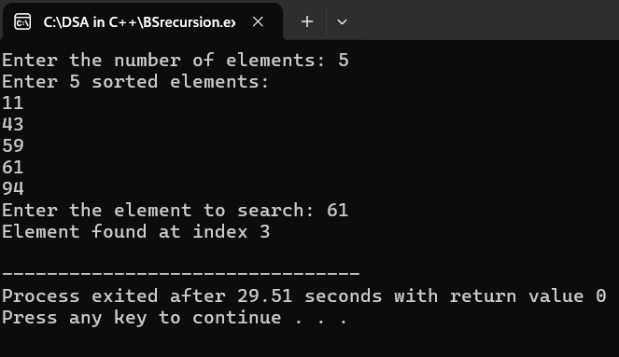

Time complexity & space complexity:

Time Complexity

Best Case: O(1)
When the middle element is the key (found in the first comparison).

Worst Case / Average Case: O(log n)
Because each step halves the search space. For n elements, maximum comparisons are about log₂(n).

Space Complexity

O(1)
Only a few extra variables (low, high, mid, key, etc.) are used, no additional data structures.

Applications & Limitations:

Applications of Binary Search

1. Searching in sorted arrays/lists
Quickly find elements in a sorted dataset (e.g., roll numbers, IDs).

2. Databases and Libraries
Used to index and quickly retrieve records.

3. Gaming / Leaderboards
To locate player scores or ranks efficiently.

4. Dictionary / Spell Checkers
To check if a word exists in a sorted word list.

5. Range searching / Lower and Upper Bound
Used in competitive programming and algorithms like lower_bound in C++ STL.

Limitations of Binary Search

1. Array must be sorted
Cannot work on unsorted data; sorting adds extra overhead (O(n log n)).

2. Random Access Required

Works efficiently only on data structures that allow direct access (like arrays, not linked lists).

3. Static Data
Not suitable if elements are frequently inserted or deleted (re-sorting is required).

4. Not suitable for very small datasets
Linear search can sometimes be faster for tiny arrays due to less overhead.

- Binary search using recursion:
#include <stdio.h>
int binarySearch(int arr[], int low, int high, int key) {
if (low > high)
return -1; // Element not found

int mid = (low + high) / 2;

if (arr[mid] == key)
return mid; // Element found
else if (arr[mid] < key)
return binarySearch(arr, mid + 1, high, key);
else
return binarySearch(arr, low, mid - 1, key); }

int main() {
int n, key, result;

printf("Enter number of elements: ");
scanf("%d", &n);

int arr[n];

printf("Enter elements in sorted order: ");
for (int i = 0; i < n; i++) {
scanf("%d", &arr[i]);
}

printf("Enter element to search: ");
scanf("%d", &key);

result = binarySearch(arr, 0, n - 1, key);

if (result == -1)
printf("Element not found\n");
else
printf("Element found at index %d\n", result);

return 0;
}

OUTPUT
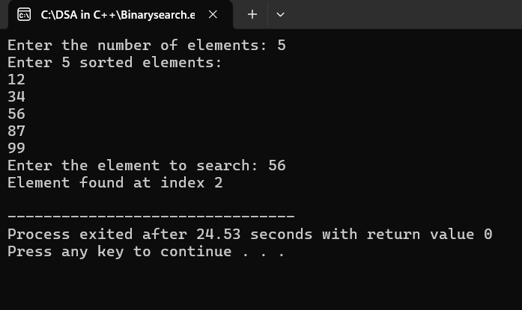

Time complexity & space complexity:

Time Complexity

Best Case: O(1)
→ When the middle element is the key (found in first call).

Worst Case / Average Case: O(log n)
→ Each recursive call halves the search range, so total calls are about log₂(n).

Space Complexity

O(log n)
→ Each recursive call adds a new function frame to the call stack.
→ For n elements, maximum recursive depth = log₂(n).

Applications & Limitations:

Applications

1. Searching in sorted arrays – Fast search in roll numbers, IDs, etc.

2. Databases/Indexing – Used in sorted datasets for quick retrieval.

3. Gaming/Leaderboards – Searching scores or rankings efficiently.

4. Dictionary/Spell Checkers – Check word existence in sorted lists.

5. Range Queries (lower/upper bound) – Common in competitive programming.

Limitations

1. Extra Space Usage

Each recursive call uses stack memory, so space complexity is O(log n).

2. Risk of Stack Overflow

For very large arrays, deep recursion may cause stack overflow.

3. Same Sorting Requirement

Array must be sorted; otherwise, it won’t work.

4. Slightly Slower than Iterative

Function calls add overhead compared to iterative binary search.

Conclusion:

This, From this experiment i understand the time and space complexity of binary search using recursion and array aslo there applications and limitations.

